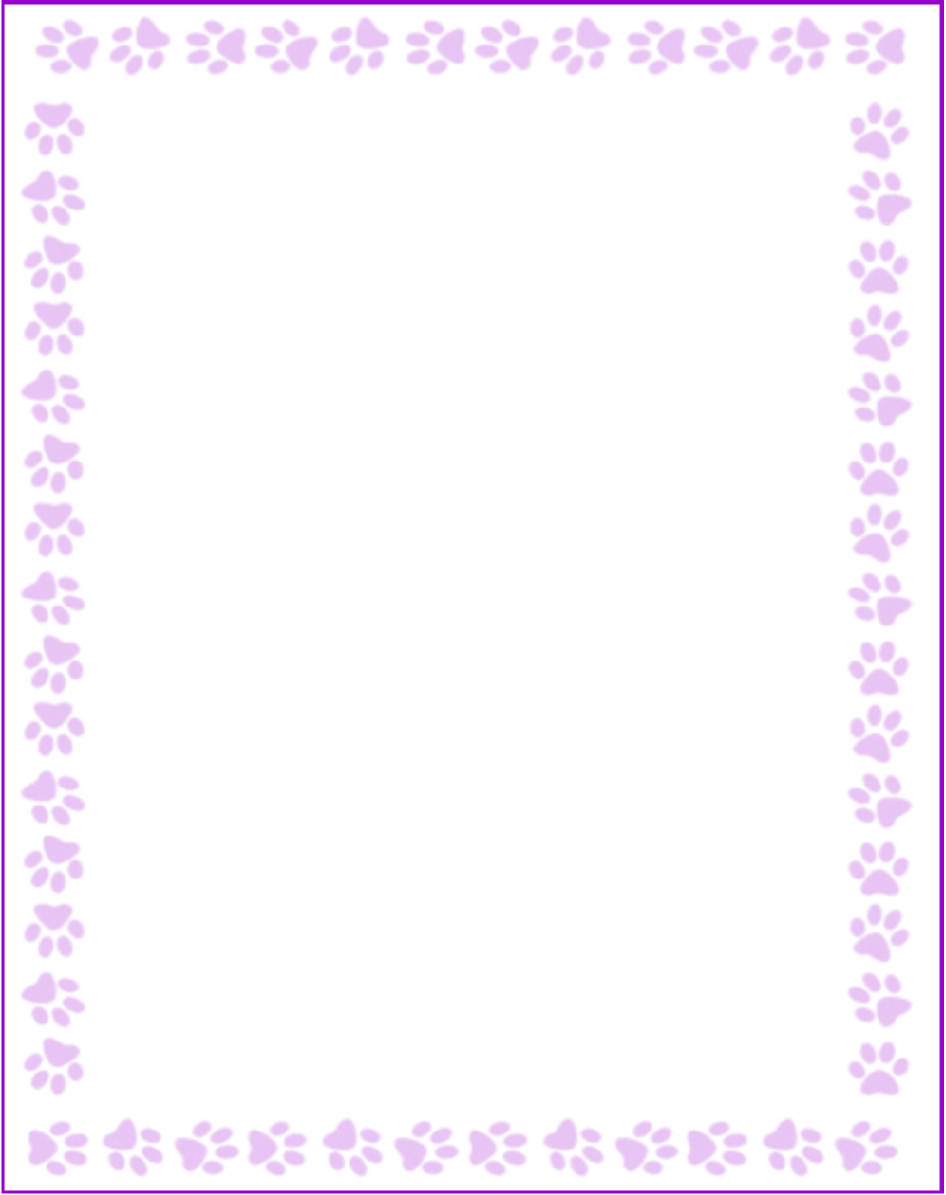

**Trina Ashedele**

|  |  |
| --- | --- |
| What is your grade/position? | Support Staff |
| When is your birthday? | 2/11 |
| What is your favorite color? | Yellow |
| What are your favorite flowers? | Allergic to flowers |
| What are your favorite collectibles? | Fun stickers |
| What is your favorite restaurant? | Shane’s or Zaxby’s |
| What is your favorite food? | Spaghetti |
| What is your favorite drink? | Diet Mountain Dew |
| What is your favorite candy? | Haribo coke bottles |
| What is your favorite store? | Target |
| What are your interests or hobbies? | Reading |
| Are you allergic to anything? Include any flavors or scents you want to avoid. | Chocolate, soy, peanuts, perfumes |