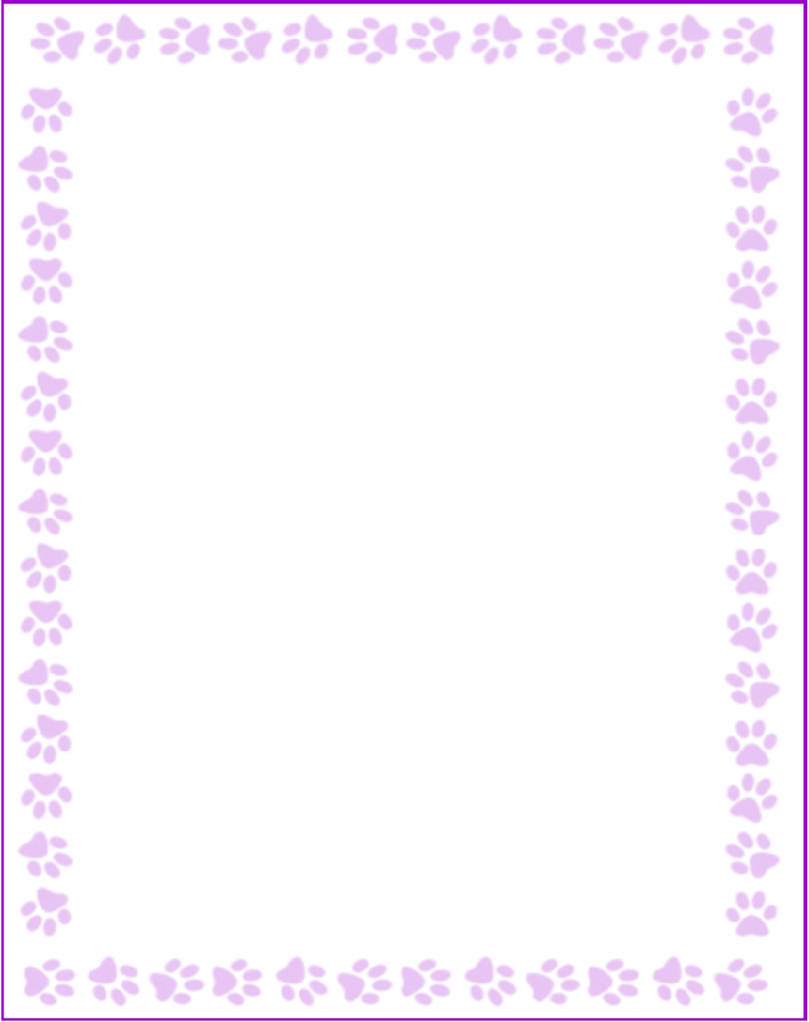

**Nicole Winters**

|  |  |
| --- | --- |
| What is your grade/position? | Fourth Grade Teacher |
| When is your birthday? | 3/6 |
| What is your favorite color? | yellow |
| What are your favorite flowers? | sunflowers |
| What are your favorite collectibles? | rubber ducks/ frog trinkets |
| What is your favorite restaurant? | Olive garden |
| What is your favorite food? | Chick-fil-a |
| What is your favorite drink? | Sweet Tea |
| What is your favorite candy? | Rollos |
| What is your favorite store? | Target or Amazon |
| What are your interests or hobbies? | painting |
| Are you allergic to anything? Include any flavors or scents you want to avoid. | please no lavender :) |