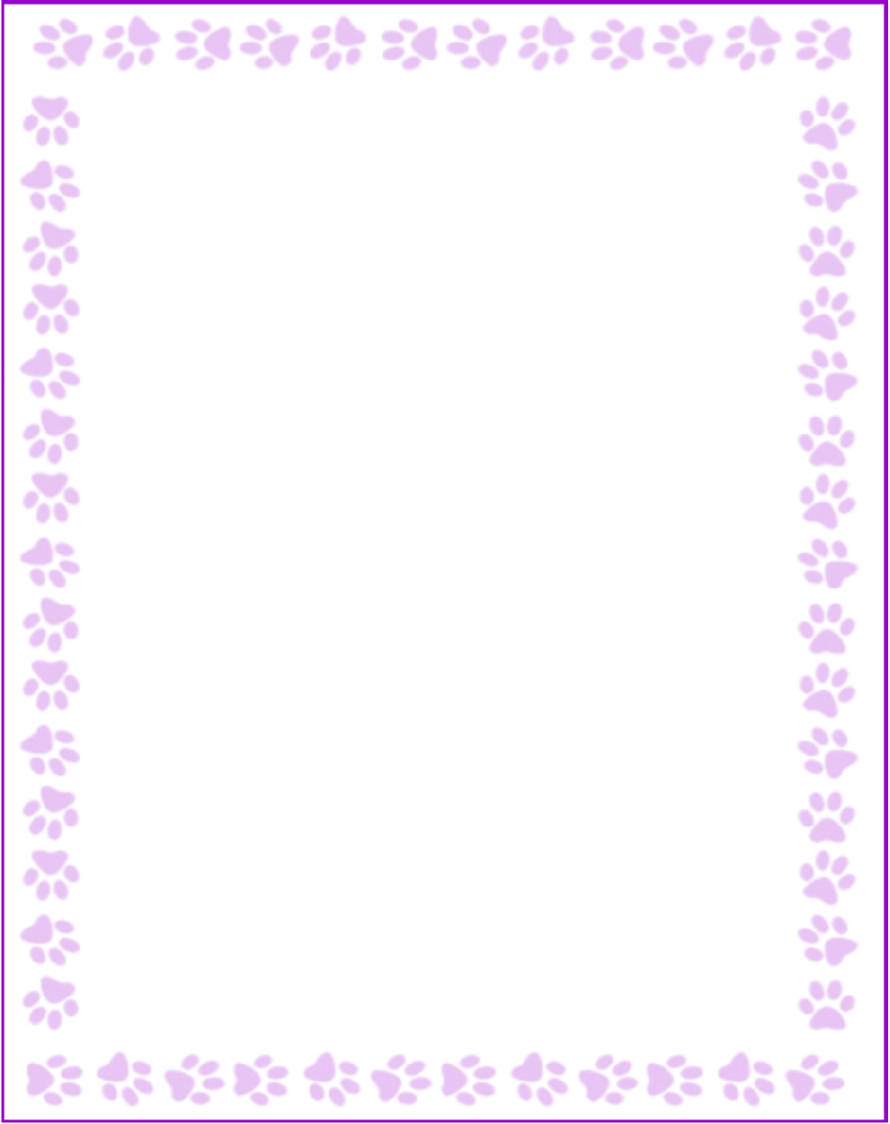

**Mary Hudson**

|  |  |
| --- | --- |
| What is your grade/position? | Support Staff |
| When is your birthday? | 6/9 |
| What is your favorite color? | green |
| What are your favorite flowers? | mixed bouquet |
| What are your favorite collectibles? | none |
| What is your favorite restaurant? | mid-eastern |
| What is your favorite food? | Italian, mid-eastern, thai/chinese |
| What is your favorite drink? | coffee |
| What is your favorite candy? | Dark Chocolate with nuts |
| What is your favorite store? | Loft, Von Maur, Macy's |
| What are your interests or hobbies? | travel, reading |
| Are you allergic to anything? Include any flavors or scents you want to avoid. | no |