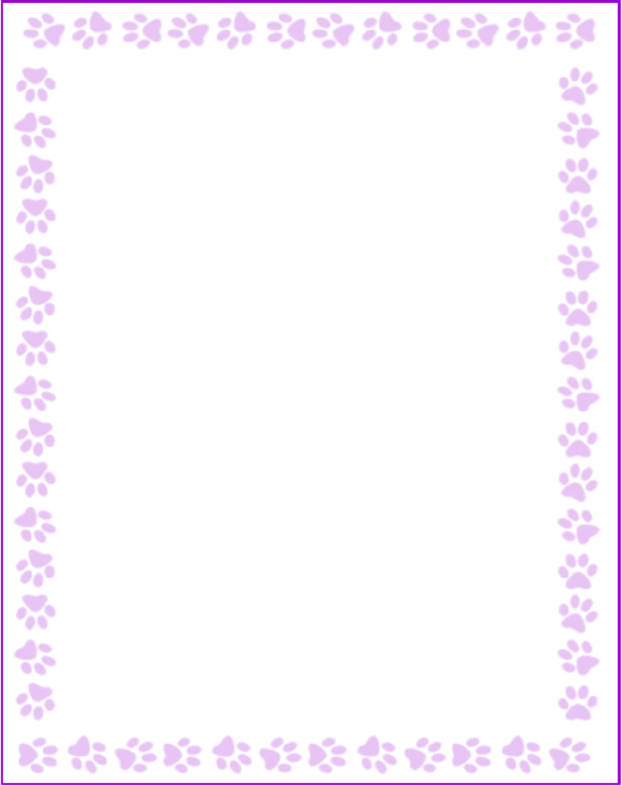

**Mary Dang**

|  |  |
| --- | --- |
| What is your grade/position? | Second Grade Teacher |
| When is your birthday? | 12/19 |
| What is your favorite color? | green and purple |
| What are your favorite flowers? | all flowers |
| What are your favorite collectibles? | dinosaur figurines |
| What is your favorite restaurant? | anywhere |
| What is your favorite food? | an over-medium egg served over rice with soy sauce and chili oil |
| What is your favorite drink? | iced matcha latte w/ oatmilk and cinnamon |
| What is your favorite candy? | n/a |
| What is your favorite store? | Amazon |
| What are your interests or hobbies? | running, photography, hiking, and metalsmithing |
| Are you allergic to anything? Include any flavors or scents you want to avoid. | n/a |