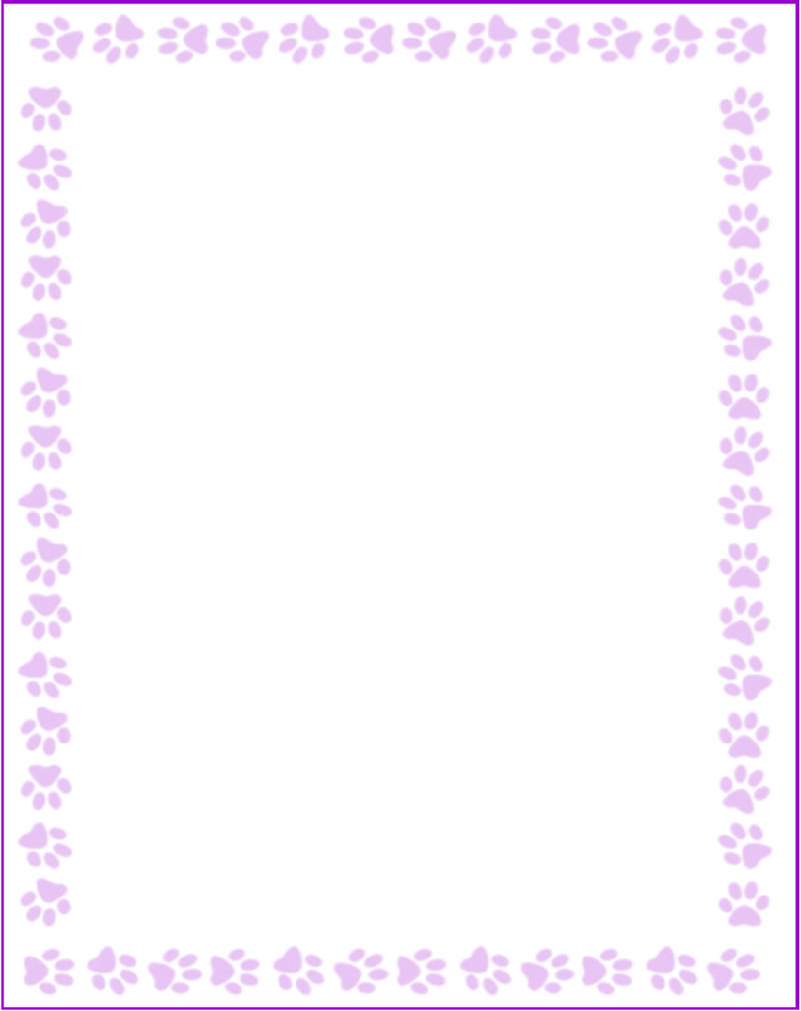

**Lyndsay Murphy**

|  |  |
| --- | --- |
| What is your grade/position? | Specials Teacher |
| When is your birthday? | 2/20 |
| What is your favorite color? | Yellow |
| What are your favorite flowers? | Any! |
| What are your favorite collectibles? | Magnets |
| What is your favorite restaurant? | Chipotle |
| What is your favorite food? | Tacos |
| What is your favorite drink? | Seltzer water |
| What is your favorite candy? | Dark chocolate |
| What is your favorite store? | Target |
| What are your interests or hobbies? | Reading |
| Are you allergic to anything? Include any flavors or scents you want to avoid. | Not a fan of strong scents in body products or candles, prefer vanilla-type scents. |