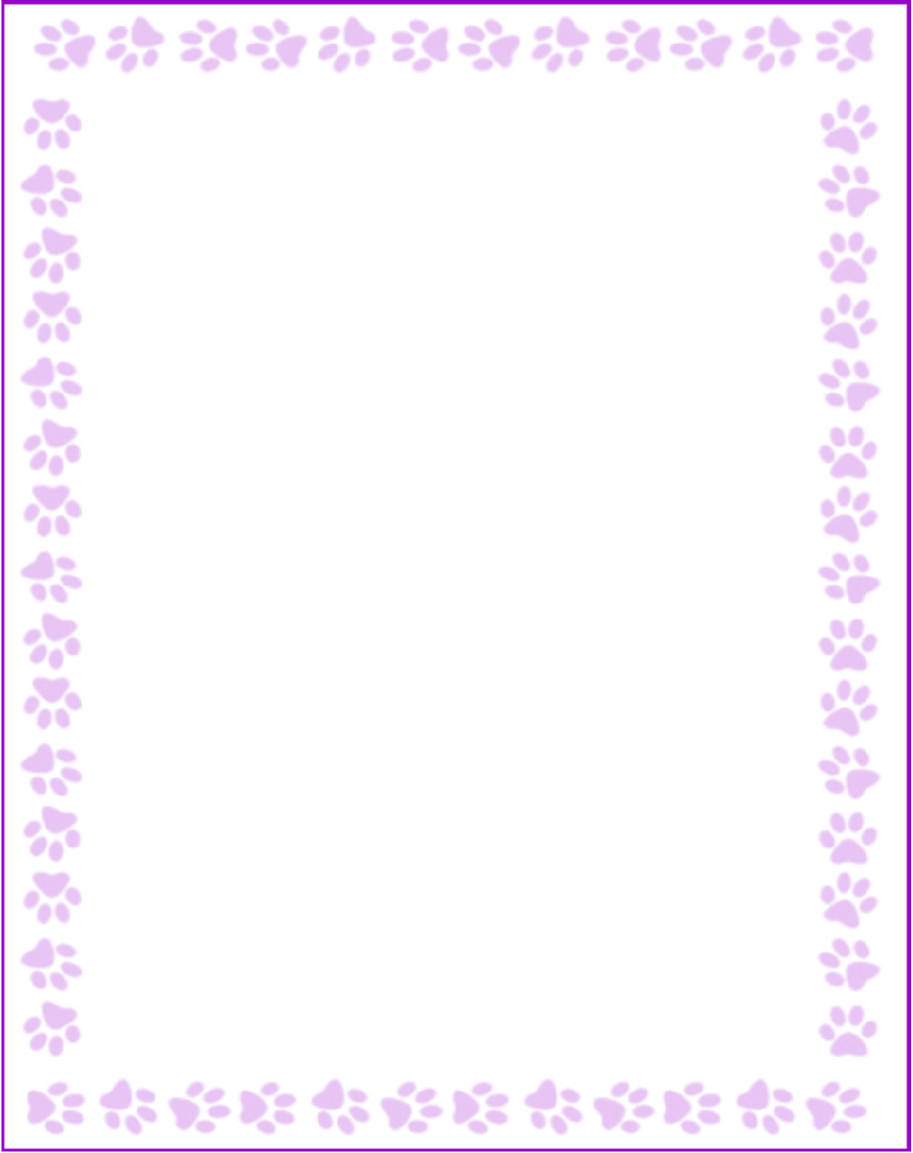

**Lauren Davidson**

|  |  |
| --- | --- |
| What is your grade/position? | Kindergarten Teacher |
| When is your birthday? | 12/26 |
| What is your favorite color? | pink |
| What are your favorite flowers? | peonies or roses |
| What are your favorite collectibles? | Nut Crackers |
| What is your favorite restaurant? | Cherry Street Brew Pub |
| What is your favorite food? | spaghetti |
| What is your favorite drink? | lemonade, 7Brew pink mermaid iced (no coconut) |
| What is your favorite candy? | gummy worms |
| What is your favorite store? | TJMaxx |
| What are your interests or hobbies? | gym and shopping |
| Are you allergic to anything? Include any flavors or scents you want to avoid. | no allergies |