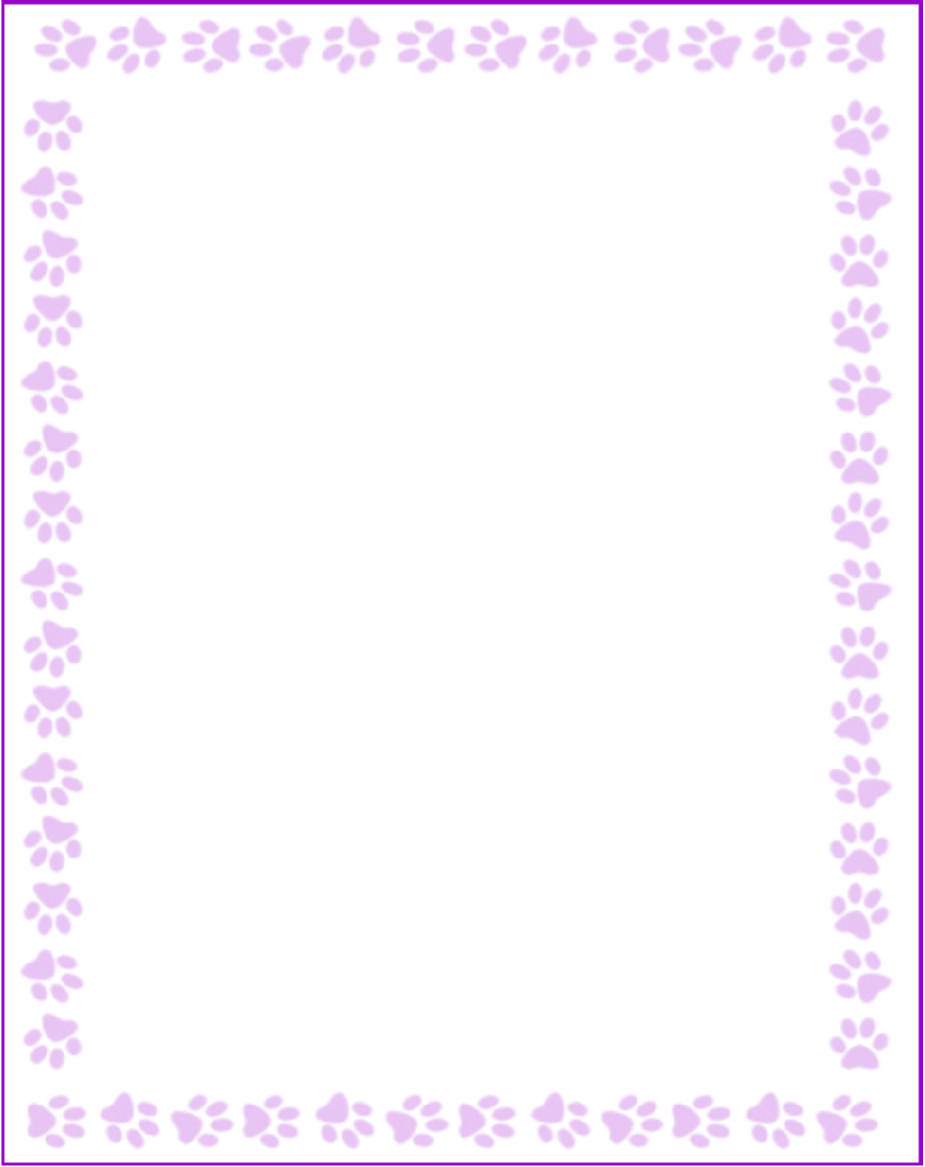

**Karen Dills**

|  |  |
| --- | --- |
| What is your grade/position? | Support Staff |
| When is your birthday? | 5/26 |
| What is your favorite color? | blue |
| What are your favorite flowers? | any |
| What are your favorite collectibles? | n/a |
| What is your favorite restaurant? | sugo |
| What is your favorite food? | pasta |
| What is your favorite drink? | black coffee |
| What is your favorite candy? | milk chocolate |
| What is your favorite store? | Personify |
| What are your interests or hobbies? | boating |
| Are you allergic to anything? Include any flavors or scents you want to avoid. | all perfumes/candles; almonds |