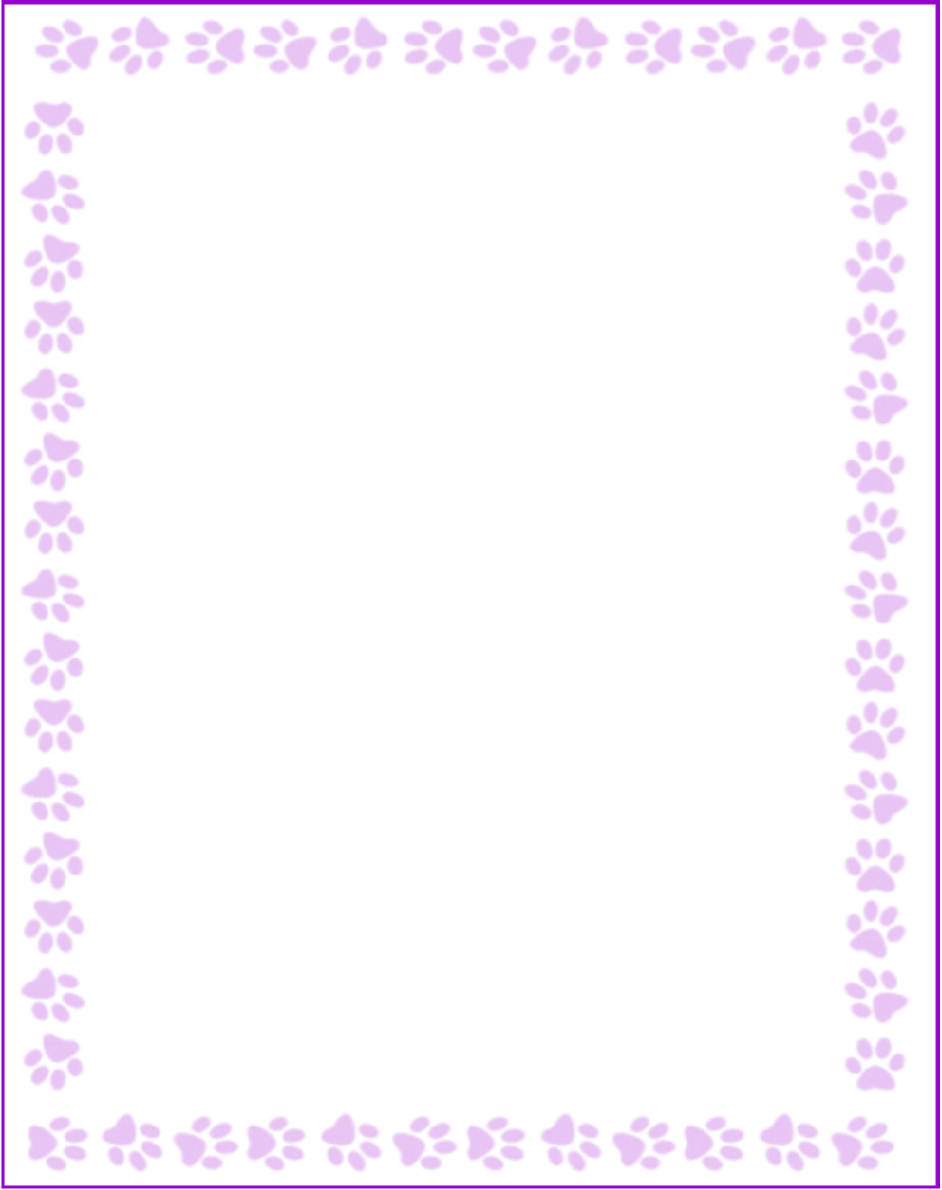

**Joanna Jo**

|  |  |
| --- | --- |
| What is your grade/position? | First Grade Teacher |
| When is your birthday? | 4/24 |
| What is your favorite color? | teal |
| What are your favorite flowers? | any flowers! |
| What are your favorite collectibles? | coffee beans |
| What is your favorite restaurant? | olive garden |
| What is your favorite food? | noodle dish |
| What is your favorite drink? | dr pepper |
| What is your favorite candy? | skittles |
| What is your favorite store? | trader joes |
| What are your interests or hobbies? | baking |
| Are you allergic to anything? Include any flavors or scents you want to avoid. | I do not like coconut scent. |