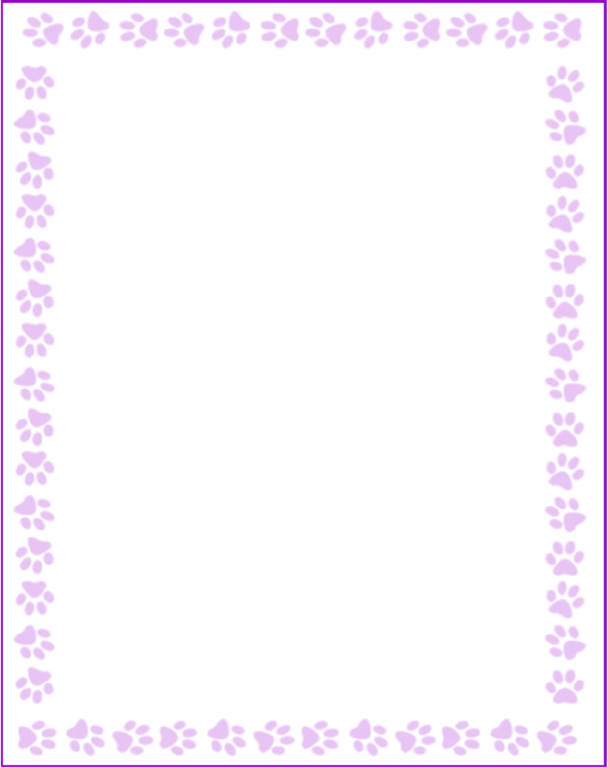

**Jasmine Bailey**

|  |  |
| --- | --- |
| What is your grade/position? | Support Staff |
| When is your birthday? | 11/13 |
| What is your favorite color? | Anything pastel |
| What are your favorite flowers? | Sunflowers |
| What are your favorite collectibles? | n/a |
| What is your favorite restaurant? | Firehouse, Chi-fil-a |
| What is your favorite food? | Cuban food, Habachi |
| What is your favorite drink? | Powerade Zero Sugar, Coffee |
| What is your favorite candy? | n/a |
| What is your favorite store? | Amazon |
| What are your interests or hobbies? | Crafting |
| Are you allergic to anything? Include any flavors or scents you want to avoid. | No flowery smells |