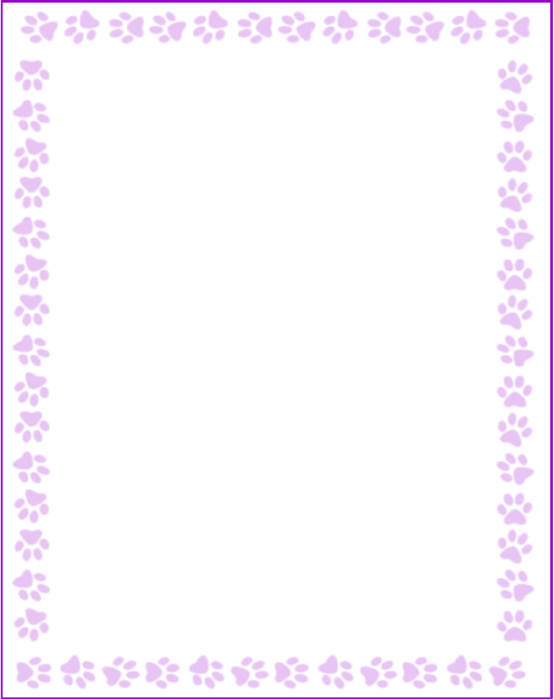

**Emma Sbat**

|  |  |
| --- | --- |
| What is your grade/position? | Pre-K Teacher |
| When is your birthday? | 12/4 |
| What is your favorite color? | Yellow & Blue |
| What are your favorite flowers? | Tulips |
| What are your favorite collectibles? | Pens |
| What is your favorite restaurant? | CFA |
| What is your favorite food? | Sushi |
| What is your favorite drink? | Dr. Pepper |
| What is your favorite candy? | sour gummy worms |
| What is your favorite store? | Target |
| What are your interests or hobbies? | Crafts, walks, baking, and reading |
| Are you allergic to anything? Include any flavors or scents you want to avoid. | NA |