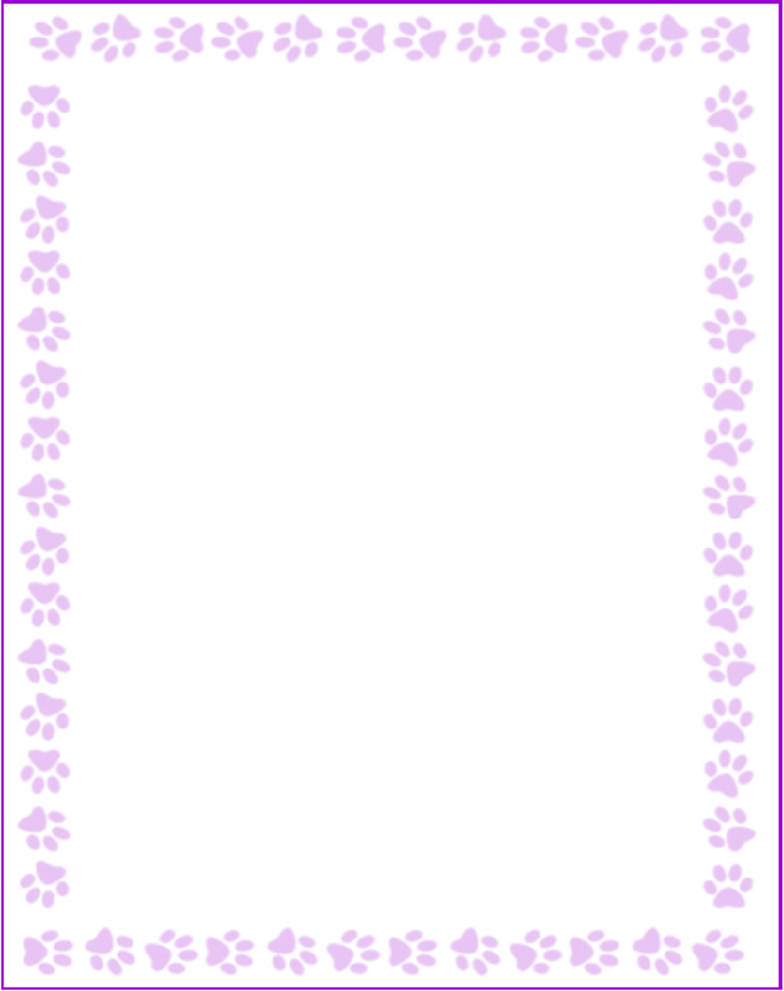

**Debra Siegel**

|  |  |
| --- | --- |
| What is your grade/position? | Other |
| When is your birthday? | 1/1 |
| What is your favorite color? | purple |
| What are your favorite flowers? | any |
| What are your favorite collectibles? | drinking glasses, tea pots, books |
| What is your favorite restaurant? | anything I am not cooking and cleaning |
| What is your favorite food? | salads, french fries, coffees, cupcakes, pizza, cookies |
| What is your favorite drink? | water, coffees, teas |
| What is your favorite candy? | chocolate |
| What is your favorite store? | I love all shopping |
| What are your interests or hobbies? | fitness, walking, cooking, gardening, reading, travel, decorating |
| Are you allergic to anything? Include any flavors or scents you want to avoid. | no |