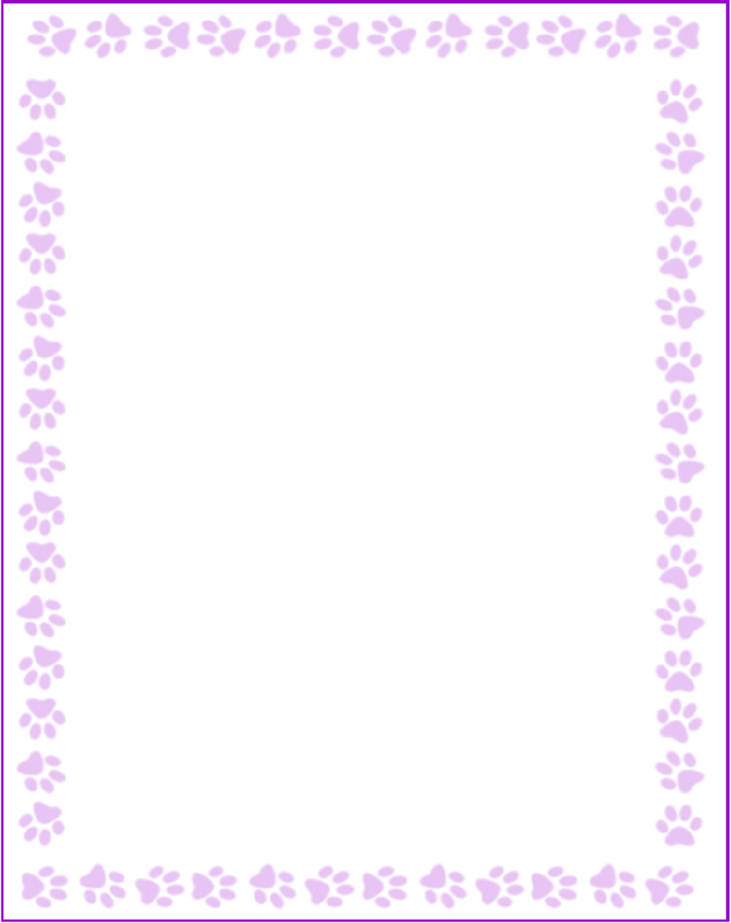

**Betsy Fenton**

|  |  |
| --- | --- |
| What is your grade/position? | Other |
| When is your birthday? | 10/25 |
| What is your favorite color? | Blud |
| What are your favorite flowers? | Any |
| What are your favorite collectibles? | Giraffes/ Snoopy |
| What is your favorite restaurant? | Chick fil A |
| What is your favorite food? | Pizza |
| What is your favorite drink? | Sparkling Water |
| What is your favorite candy? | Reeses cups and M&Ms |
| What is your favorite store? | Amazon |
| What are your interests or hobbies? | Readings |
| Are you allergic to anything? Include any flavors or scents you want to avoid. | Like pumpkin scent candles |