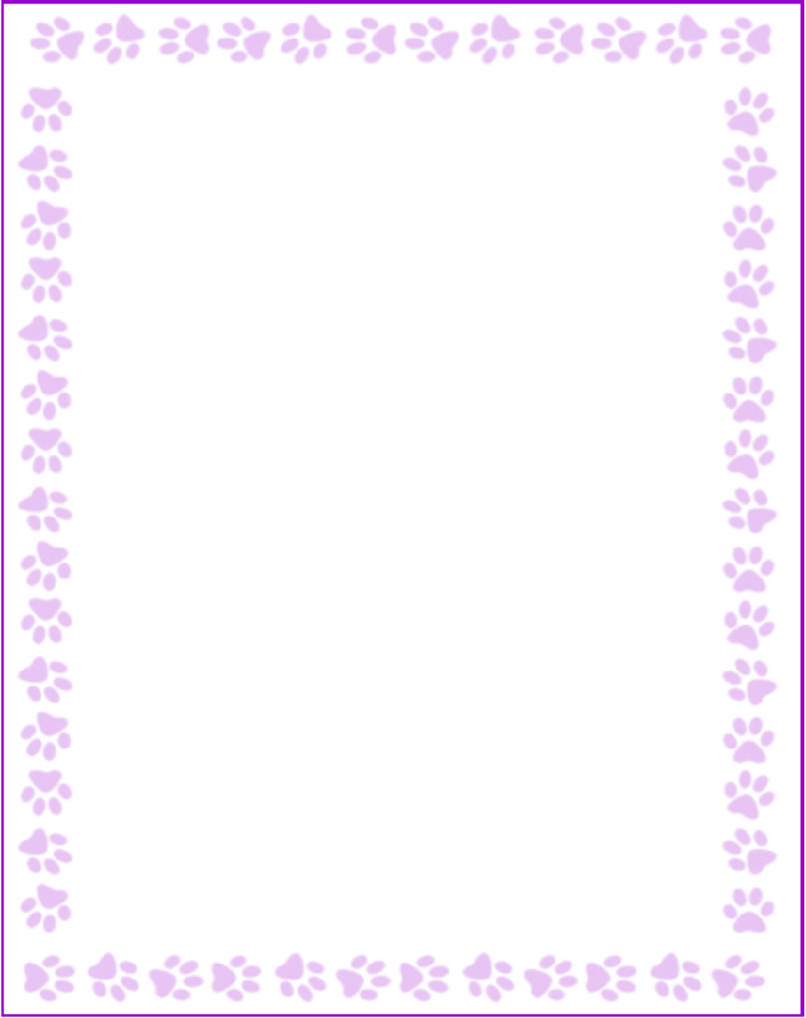

**Sandra Olvera**

|  |  |
| --- | --- |
| Grade or Position: | Parent Liaison |
| Birthday: | 08/01 |
| Favorite Candy: | Chocolate |
| Favorite: Color | green |
| Favorite Flowers: | girasol |
| Favorite Collectibles: | candle |
| Favorite Food: | sushi |
| Favorite Store: | barns and noble |
| Favorite Drink: | cappuccino |
| Favorite Restaurant: | 7 Tequilas |
| Interests and Hobbies: | byclicle |
| Things I have too many of: | books |
| Something I would like you to know about me: | I love travel |
| Things I am allergic to: | no |
| Other comments: |  |