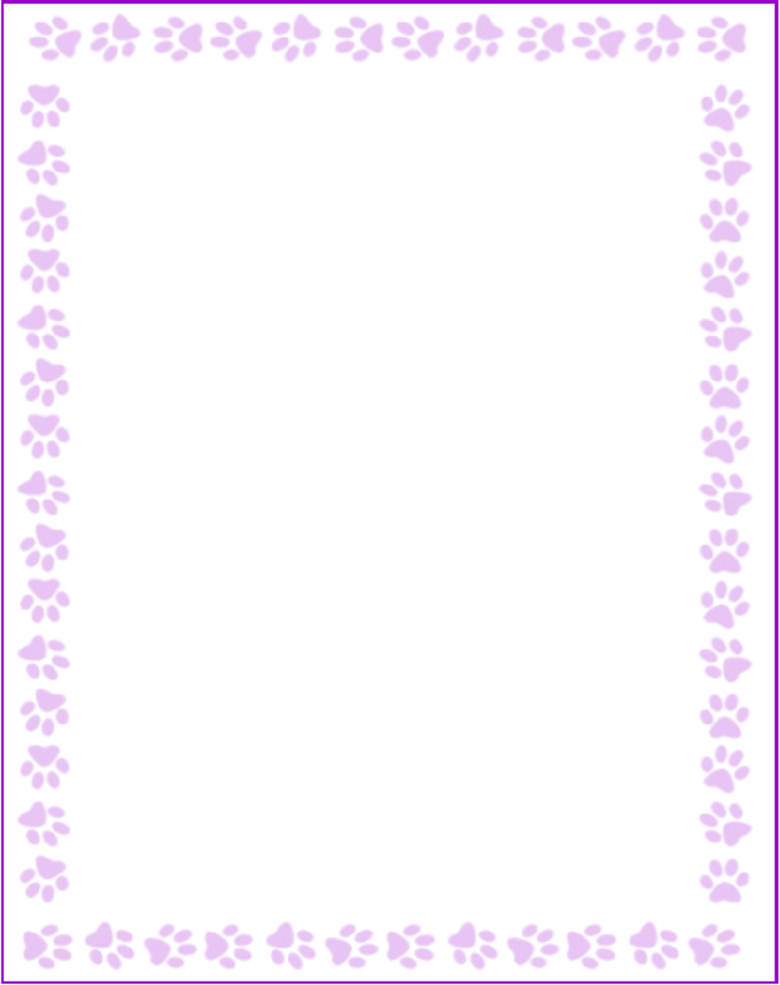

**Samantha L. Bush**

|  |  |
| --- | --- |
| Grade or Position: | Kindergarten Teacher |
| Birthday: | February 4th |
| Favorite Candy: | Trolli worms |
| Favorite: Color | Pink |
| Favorite Flowers: | Pink Roses |
| Favorite Collectibles: | Stickers |
| Favorite Food: | Pasta |
| Favorite Store: | Target, Old Navy |
| Favorite Drink: | Diet Coke |
| Favorite Restaurant: | Chickfila, any Mexican food |
| Interests and Hobbies: | Being with my family and friends |
| Things I have too many of: | Scrunchies |
| Something I would like you to know about me: | I'm always snacking! |
| Things I am allergic to: | No allergies :) |
| Other comments: |  |