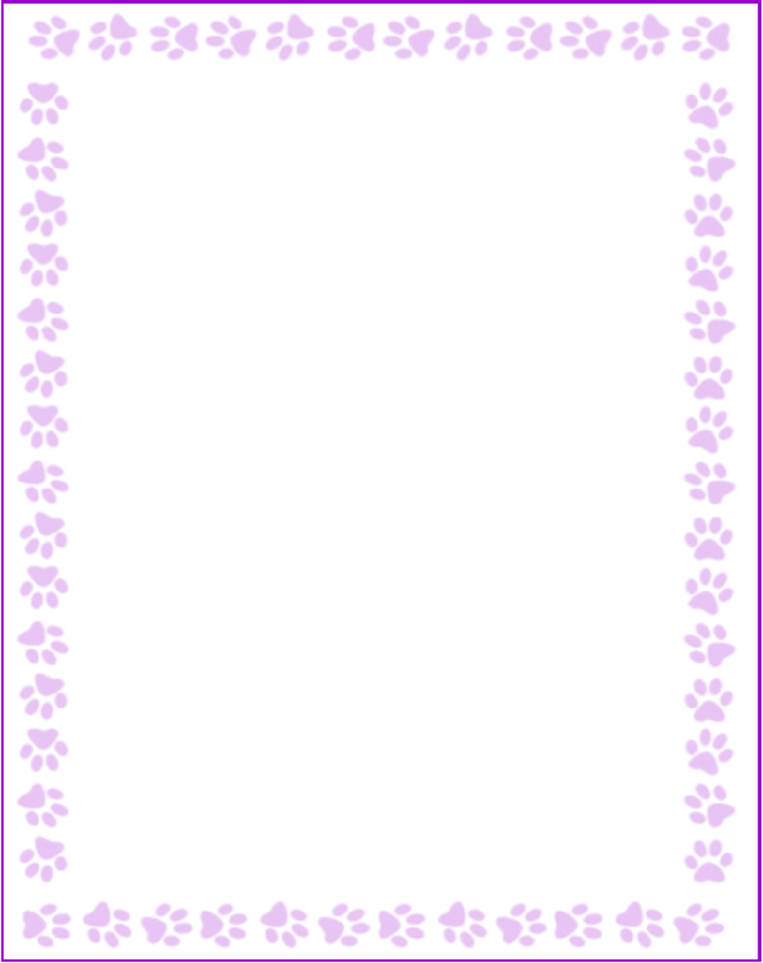

**S. Colette Bingham**

|  |  |
| --- | --- |
| Grade or Position: | Media Clerk |
| Birthday: | 02/25 |
| Favorite Candy: | Reese's Pieces |
| Favorite: Color | Green and Purple |
| Favorite Flowers: | Peony |
| Favorite Collectibles: | Fleur-de-lis (what can I say-I'm from Louisiana) |
| Favorite Food: | Mexican Food |
| Favorite Store: | Target & Barnes and Noble |
| Favorite Drink: | Spindrift Sparkling Water -Lemon Flavor |
| Favorite Restaurant: | Chick-fil-a |
| Interests and Hobbies: | Read, watch movies and time at the beach |
| Things I have too many of: | Travel coffee cups and water bottles |
| Something I would like you to know about me: | I'm a huge New Orleans Saints Fan! WHO DAT! |
| Things I am allergic to: |  |
| Other comments: |  |