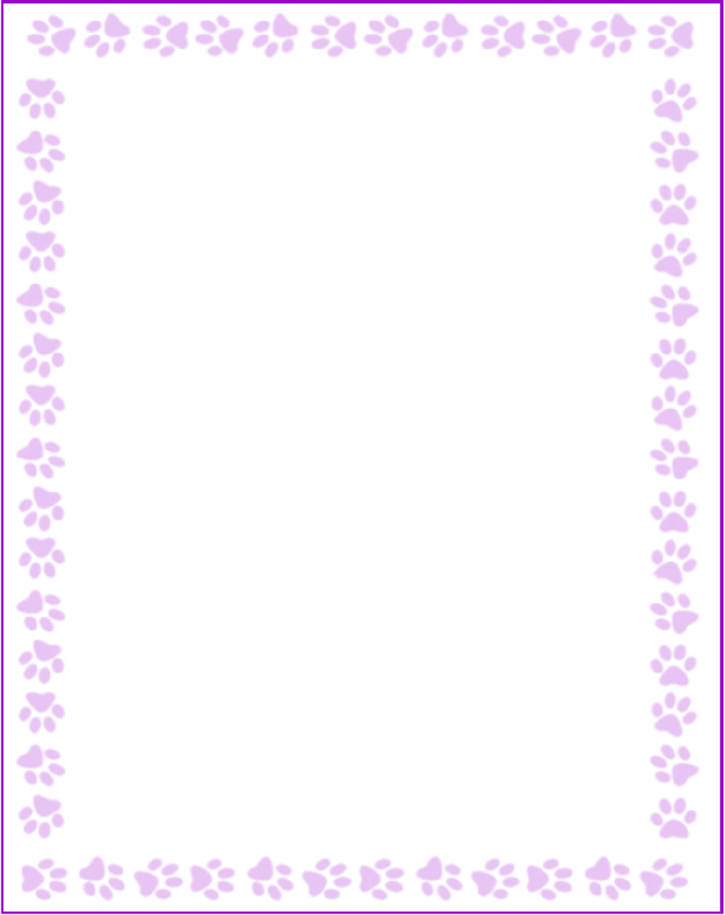

**Niki T Norby**

|  |  |
| --- | --- |
| Grade or Position: | Media Specialist |
| Birthday: | February 21 |
| Favorite Candy: | Dark Chocolate Covered Almonds or Dark Chocolate with Caramel/Sea Salt |
| Favorite: Color | Periwinkle Blue or Lavender Purple |
| Favorite Flowers: | Hydrangeas and Daisies |
| Favorite Collectibles: | PaperMate Pens |
| Favorite Food: | Original Goldfish |
| Favorite Store: | TJ Maxx and Target |
| Favorite Drink: | Hot Green Tea (Decaffeinated) |
| Favorite Restaurant: | Chick-Fil-A and Newk's |
| Interests and Hobbies: | Reading and Pilates |
| Things I have too many of: | Nail Polish |
| Something I would like you to know about me: | I love reading to my students and in my spare time! |
| Things I am allergic to: | Media Specialist |
| Other comments: | No |