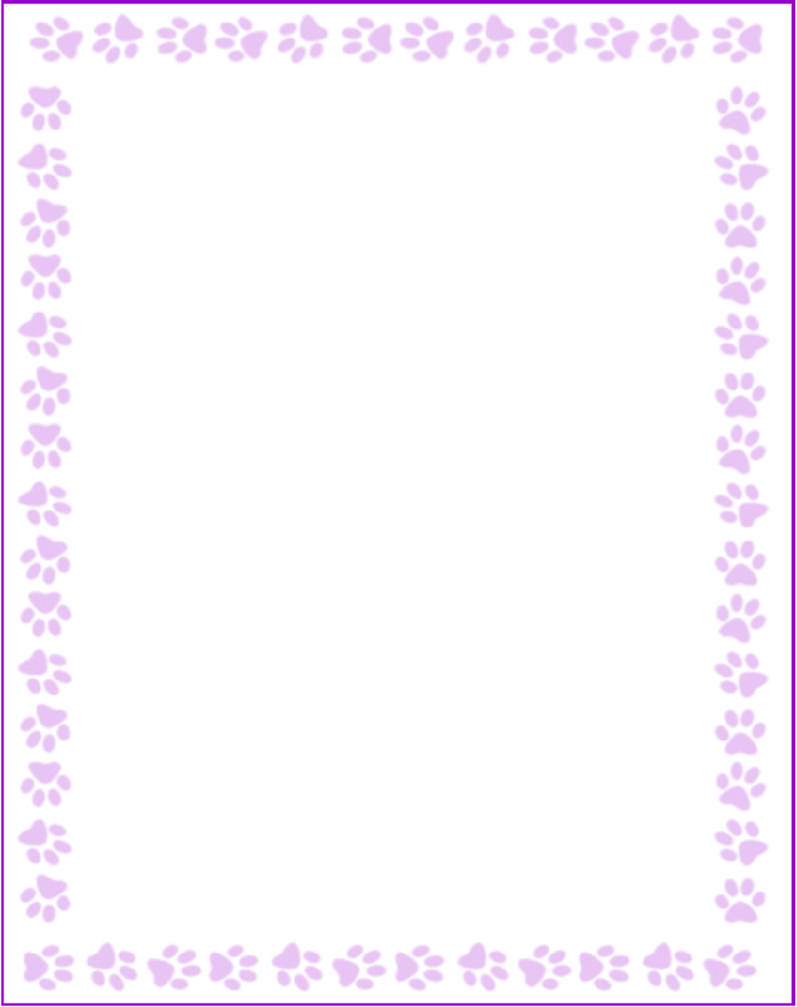

**Mary Hudson**

|  |  |
| --- | --- |
| Grade or Position: | K-parapro |
| Birthday: | 6/9 |
| Favorite Candy: |  |
| Favorite: Color | green |
| Favorite Flowers: | mixed-but not lilies |
| Favorite Collectibles: | none |
| Favorite Food: | Italian |
| Favorite Store: | Macys/Von Maur/Dillards |
| Favorite Drink: | Starbucks-"medicine ball" (mint tea) |
| Favorite Restaurant: | Kurt's Bistro, Rumi's KItchen |
| Interests and Hobbies: | traveling, cooking, reading |
| Things I have too many of: | books (including recipe books) |
| Something I would like you to know about me: | I love to take walks and spend time with my family |
| Things I am allergic to: | none |
| Other comments: |  |