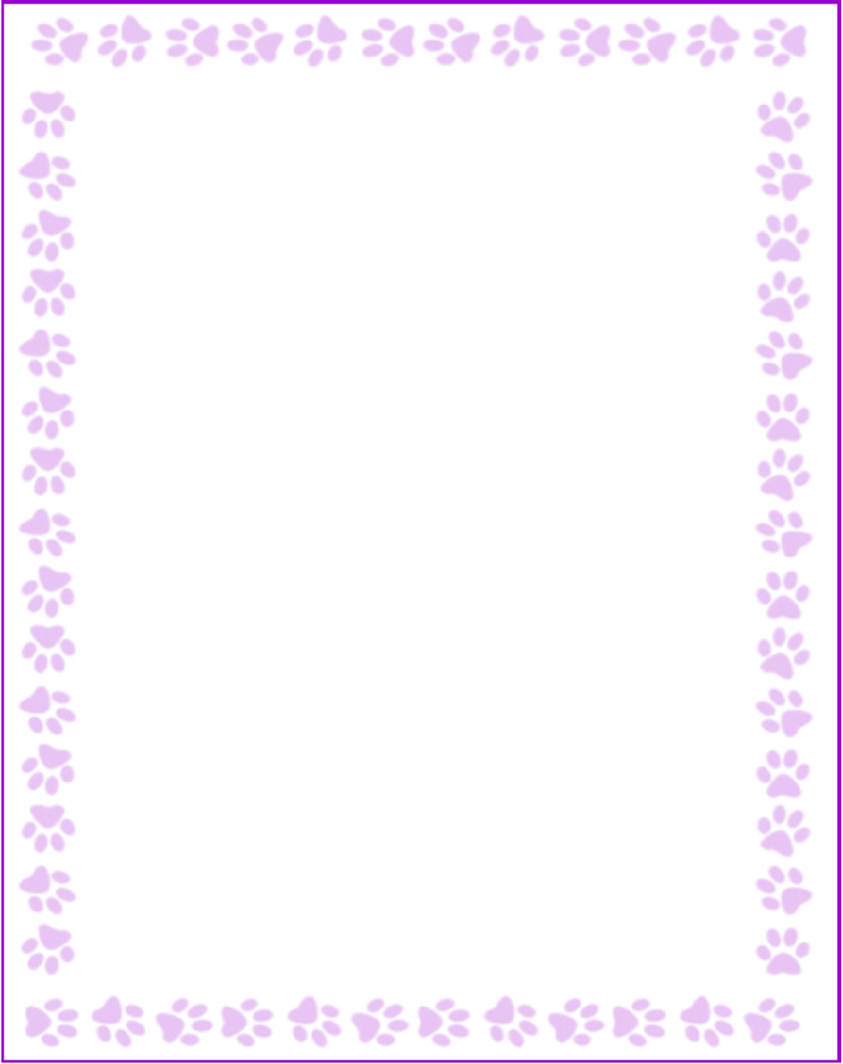

**Karen L.M. Dills**

|  |  |
| --- | --- |
| Grade or Position: | EIP |
| Birthday: | May 26 |
| Favorite Candy: | milk chocolate |
| Favorite: Color |  |
| Favorite Flowers: | mini roses |
| Favorite Collectibles: |  |
| Favorite Food: | pasta |
| Favorite Store: |  |
| Favorite Drink: | black |
| Favorite Restaurant: | sugo |
| Interests and Hobbies: | sports |
| Things I have too many of: |  |
| Something I would like you to know about me: |  |
| Things I am allergic to: | almonds |
| Other comments: |  |