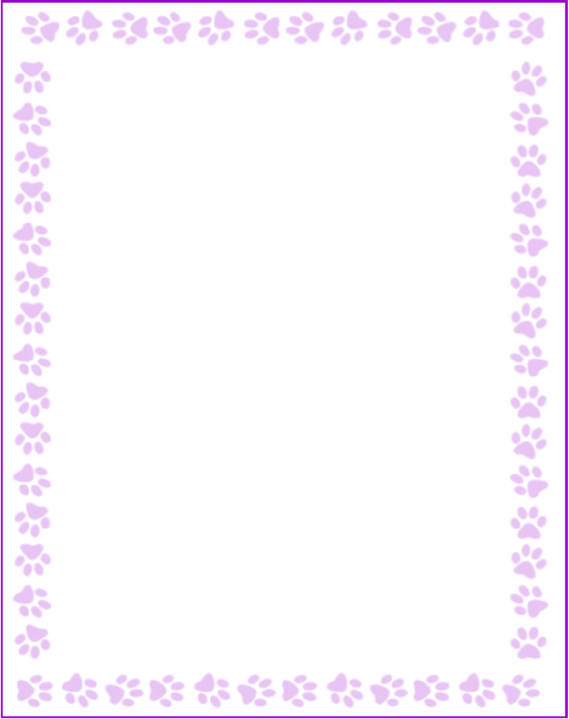

Teacher and Staff Favorites List

|  |  |
| --- | --- |
| Name: | Fakhra Zuberi |
| Grade or Position: | Technology Special |
| Birthday: | July 15 |
| Favorite Candy: | KitKat |
| Favorite Color: | Blue |
| Favorite Flowers: | Hydrangeas and Tulips |
| Favorite Collectibles: | Candles and soaps |
| Favorite Food: | Thai and Chick fil A |
| Favorite Store: | Home Goods and Nordsdrom |
| Favorite Restaurant: | Dunkin Donuts, Marlows Tavern |
| Interests and Hobbies: | Gardening and reading books |
| Things I have too many of: |  |
| Things I am allergic to: | NA |
| Other comments: | I have 4 kids and 3 Grand childrens No Pets |